DEVELOP A PASSWORD BASED LED CONTROL SYSTEM USING ARDUINO UNO GIVE ABSTRACT

A MINI PROJECT REPORT
Submitted by

HARINI L 312325106055
in partial fulfillment for the award of the degree of

BACHELOR OF ENGINEERING
IN

ELECTRONICS AND COMMUNICATION ENGINEERING




St. JOSEPH’S COLLEGE OF ENGINEERING (An AUTONOMOUS INSTITUTION) CHENNAI - 600 119

ANNA UNIVERSITY: CHENNAI 600 025



DEVELOP A PASSWORD BASED LED CONTROL SYSTEM USING ARDUINO UNO GIVE ABSTRACT

A MINI PROJECT REPORT

Submitted by

HARINI L 312323106055
in partial fulfillment for the award of the degree of

BACHELOR OF ENGINEERING
IN

ELECTRONICS AND COMMUNICATION ENGINEERING

St. JOSEPH’S COLLEGE OF ENGINEERING (An AUTONOMOUS INSTITUTION) CHENNAI - 600 119

ANNA UNIVERSITY: CHENNAI 600 025


DEPARTMENT OF ELECTRONICS AND COMMUNICATION ENGINEERING BATCH: 2025-2029 (III SEM)
MINI PROJECT EVALUATION SHEET

Project Title | :
Student Name | :
Register Number | :
Date of Evaluation | :

Evaluation Criteria

S.No | Criteria | Maximum Marks | Marks Awarded
1 | Project Concept & Relevance | 10
2 | Design & Implementation | 10
3 | Presentation & Documentation | 10
Total |  | 30
Total

Evaluator Name and Signature

ABSTRACT

This project presents a password-based LED control system built on the Arduino Uno microcontroller. The system demonstrates the principle of secure access control, in which a load, represented here by an LED, can be operated only after the user is authenticated. Ordinary switches offer no protection against unauthorized use, which is a limitation in homes, laboratories and industries where controlled access to devices is needed.
The system uses a 4×4 matrix keypad as the input, the Arduino Uno (ATmega328P) as the processing unit, and an LED, a 16×2 I2C LCD and a buzzer as the outputs. The user enters a numeric password, which is masked with asterisks on the display. When the submit key is pressed, the Arduino compares the entry with the stored password. A correct entry switches the LED on and displays "Access Granted". An incorrect entry keeps the LED off, sounds the buzzer and displays "Wrong Password". After three consecutive wrong attempts, the keypad is locked for a fixed period to prevent brute-force guessing.
The program was written in the Arduino IDE using the Keypad and LiquidCrystal_I2C libraries. The design was verified through simulation and then implemented on a breadboard prototype. Test cases covering correct and incorrect passwords, repeated failures, input clearing and re-locking were carried out, and the system responded correctly in all cases with a very fast response time.
The proposed system is low-cost, simple and easy to modify. It can be extended by adding a relay module to control appliances or a door lock, and by adding RFID or fingerprint authentication, Bluetooth or Wi-Fi control and access logging. It therefore provides a practical foundation for smart home automation, door access control and industrial switching applications.
Keywords: Arduino Uno, Password Authentication, Keypad, LED Control, Access Control, Embedded Systems, Home Automation.

As before, remove any feature (such as the lockout) that you did not actually implement. This version is about 230 words, suitable for a one-page abstract.

TABLE OF CONTENTS

Chapter No. | Title | Page
 | Acknowledgement | iv
 | Abstract | v
 | List of Figures / List of Tables | ix / x
 | List of Symbols and Abbreviations | xi
 | SDG Goals Mapping | xii
1 | INTRODUCTION | 1
 | 1.1 Background and Motivation | 1
 | 1.2 Technological Approach | 2
 | 1.3 Challenges and Vision | 2
 | 1.4 Objectives | 3
 | 1.5 Organisation of the Report | 4
 | 1.6 Conclusion | 5
2 | LITERATURE SURVEY | 6
 | 2.1 Evolution of Embedded Access Control Systems | 6
 | 2.2 Keypad-Based Password Systems | 6
 | 2.3 Advanced Authentication Techniques | 7
 | 2.4 Conclusion | 8
3 | METHODOLOGY | 9
 | 3.1 Limitations of Existing Systems | 9
 | 3.2 Advantages of the Proposed System | 9
 | 3.3 Flowchart | 10
 | 3.4 System Architecture (Block Diagram) | 11
 | 3.5 Hardware Description | 12
 | 3.6 Software Description | 13
 | 3.7 Circuit Connections and Working Principle | 14
 | 3.8 Performance Evaluation Parameters | 15
 | 3.9 Conclusion | 15
4 | RESULTS AND DISCUSSION | 16
 | 4.1 Experimental Setup | 16
 | 4.2 Simulation Results | 17
 | 4.3 Hardware Implementation Results | 18
 | 4.4 Test Cases and Observations | 19
 | 4.5 Response Time and Reliability Analysis | 20
 | 4.6 Conclusion | 21
5 | CONCLUSION | 22
 | 5.1 Conclusion | 22
 | 5.2 Suggestions for Future Work | 22
 | References | 24
 | Appendix A (Arduino Program, Component List) | 26

LIST OF FIGURES

FIGURE NO.

TITLE PAGE NO

3.1 | Flowchart of the Password-Based LED Control System | 10
3.2 | Block Diagram of the System Architecture | 11
3.3 | Circuit Diagram of the Arduino Uno with Keypad, LCD, LED and Buzzer | 14
4.1 | Simulation Output: LED OFF (Initial State, "Enter Password") | 17
4.2 | Simulation Output: Wrong Password Entered (Buzzer ON, LED OFF) | 17
4.3 | Simulation Output: Correct Password Entered (LED ON, "Access Granted") | 18
4.4 | Hardware Prototype of the Password-Based LED Control System | 18
4.5 | LCD Display Messages During Different Operating States | 19
4.6 | System Lockout After Three Wrong Attempts | 20

LIST OF TABLE

Table No. | Title | Page No.
3.1 | Components Used in the Proposed System | 12
3.2 | Pin Connections between Arduino Uno and Peripherals | 14
4.1 | Test Cases and Observations | 19
4.2 | Response Time Measurements | 20

LIST OF ABBREVIATIONS

          - LED (Light Emitting Diode)
          - LCD (Liquid Crystal Display),
          - I2C (Inter-Integrated Circuit),
          - EEPROM (Electrically Erasable Programmable Read-Only emory)
          - IDE (Integrated Development Environment)
          - GPIO (General Purpose Input/Output)
          - PWM (Pulse Width Modulation)
          - RFID (Radio Frequency Identification)

MAPPING OF SDG

Project Title: Develop

 | SDG 1 | SDG 2 | SDG 3 | SDG 4 | SDG 5 | SDG 6 | SDG 7 | SDG 8 | SDG 9 | SDG 10 | SDG 11 | SDG 12 | SDG 13 | SDG 14 | SDG 15 | SDG 16 | SDG 17
High  (3) |  |  |  |  |  |  |  |  | ✓ |  | ✓
Medium (2) |  |  | ✓ |  |  |  |  |  |  |  |  |  | ✓
Low (1) |  |  |  |  |  |  |  |  |  |  |  | ✓

SDG 1 – No Poverty | SDG 2 – Zero Hunger | SDG 3 – Good Health and Well-Being | SDG 4 – Quality Education | SDG 5 – Gender Equality | SDG 6 – Clean Water and Sanitation | SDG 7 – Affordable and Clean Energy | SDG 8 – Decent Work and Economic Growth
| SDG 9 – Industry, Innovation and Infrastructure | SDG 10 – Reduced Inequalities | SDG 11 – Sustainable Cities and Communities |
SDG 12 – Responsible Consumption and Production | SDG 13 – Climate Action | SDG 14 – Life Below Water | SDG 15 – Life on Land
| SDG 16 – Peace, Justice and Strong Institutions | SDG 17 – Partnerships for the Goals

SDG | Level | Justification
SDG 9 – Industry, Innovation and Infrastructure | High (3) | Embedded electronics and automation for secure, modern infrastructure
SDG 11 – Sustainable Cities and Communities | Medium (2) | Basis for smart home and building access systems
SDG 4 – Quality Education | Medium (2) | Hands-on learning of embedded systems
SDG 7 – Affordable and Clean Energy | Low (1) | Low-power design and controlled usage of devices

CHAPTER 1 INTRODUCTION

BACKGROUND AND MOTIVATION

Electrical and electronic devices are now part of almost every activity, from lighting in a home to machinery in a factory. In most cases these devices are operated by ordinary mechanical switches, which have no ability to identify who is using them. Anyone within reach of a switch can turn a device on or off. This is acceptable for everyday lighting, but it becomes a serious problem where equipment is costly, sensitive or dangerous when misused, such as laboratory instruments, server rooms, industrial machines and secured doors.
With the growth of home automation, smart buildings and industrial automation, the demand for controlled access to devices has increased greatly. Traditional solutions such as mechanical keys are easy to lose, copy or pick. Commercial electronic access systems and biometric locks are effective but are often expensive, complex to install and difficult for students or small users to modify.
The arrival of low-cost embedded platforms such as the Arduino has changed this situation. The Arduino Uno is an open-source, easy-to-program board built around the ATmega328P microcontroller. It allows a student to design a complete electronic security system with a few inexpensive components. This project is motivated by the need for a simple, affordable and reliable authentication system that demonstrates the working principle of access control. Here, an LED represents the controlled load. It can be switched on only when the user enters the correct password on a keypad. The same design can later be extended to control lamps, relays, door locks and other appliances.

TECHNOLOGICAL APPROACH

The proposed system follows an input–process–output architecture. A 4×4 matrix keypad is the input device through which the user enters the password. The Arduino Uno is the processing unit. It scans the keypad, reads each keypress and stores the digits in a temporary buffer. When the user presses the submit key, the controller compares the buffer with the password stored in memory.
If the entered password matches, the Arduino sets the output pin connected to the LED to a high level, and the LED glows. At the same time, a 16×2 LCD connected through an I2C module displays "Access Granted". If the password does not match, the LED stays off, the buzzer sounds and the LCD displays "Wrong Password". A counter records consecutive failed attempts. When it reaches three, the system disables the keypad for a fixed period. This lockout protects against guessing by repeated trials.
The software is written in the Arduino IDE using C/C++. The Keypad library handles matrix scanning and debouncing, and the LiquidCrystal_I2C library drives the display. The EEPROM library can optionally store the password permanently, so it is not lost when power is removed and can be changed by the user. The design was first checked in a simulation environment and then built on a breadboard for testing.

CHALLENGES AND VISION

Designing even a simple password-based system involves several challenges. The first is keypad debouncing. Mechanical keys produce rapid on–off signals when pressed, which can register a single press as several. The software must filter these signals. The second is security against guessing. A system that allows unlimited attempts can be broken by trial and error, so a lockout mechanism is necessary. The third is password protection. A password stored in program code is visible to anyone who reads the code, and the password shown on the screen can be seen by onlookers, so masking is required. The fourth is cost and simplicity. The system must remain inexpensive and easy to build while still giving reliable operation.
Another challenge is electrical safety and pin limits. The Arduino pins supply only limited current, so the LED needs a current-limiting resistor, and larger loads must be driven through a relay or transistor rather than directly.
The long-term vision of this project is to grow this basic design into a complete smart access controller. Future versions could control real appliances through relays, support wireless control through Bluetooth or Wi-Fi, use RFID or fingerprint authentication for stronger security, send alerts on intrusion attempts and keep a time-stamped record of every access. In this way the project can serve as a foundation for smart home and industrial automation.

OBJECTIVES

The primary objectives of this project are:

To design and implement a password-based LED control system using the Arduino Uno microcontroller.

To interface a 4×4 matrix keypad, LED, 16×2 I2C LCD and buzzer with the Arduino Uno.

To read the password entered by the user, verify it against the stored password and control the LED accordingly.

To provide clear visual and audible feedback for correct and incorrect entries.

To implement a lockout mechanism that disables the system after three consecutive wrong attempts.

To verify the working of the system through simulation and hardware testing.

To study how the system can be extended for real-world applications such as door locks and home automation.

ORGANISATION OF THE REPORT

This report is organised into five chapters that present the design, implementation and evaluation of the password-based LED control system using Arduino Uno.

Chapter 1 – Introduction presents the background and motivation behind secure access control of electrical devices. It discusses the limitations of ordinary switches and mechanical locks, and explains why a low-cost Arduino-based solution is suitable. The chapter also outlines the technological approach, the challenges faced in designing such a system, the long-term vision and the objectives of the project.
Chapter 2 – Literature Survey reviews existing research and projects related to embedded access control systems. It discusses the evolution from mechanical locks to microcontroller-based systems, keypad-based password systems, and advanced authentication techniques such as RFID, fingerprint, GSM and IoT-based smart locks. The chapter also identifies the gaps in existing simple keypad-based designs.
Chapter 3 – Methodology describes the design and implementation of the proposed system. It explains the limitations of existing systems, the advantages of the proposed system, the flowchart and the system architecture. It also gives a detailed description of the hardware components, the software and libraries used, the circuit connections and the working principle. The parameters used to evaluate the system are defined at the end of the chapter.
Chapter 4 – Results and Discussion presents the experimental setup and the results obtained from simulation and hardware implementation. It includes the test cases and observations, the response time and reliability analysis, and a discussion of the performance and limitations of the system.
Chapter 5 – Conclusion summarises the key findings and contributions of the project. It also suggests possible improvements and future directions, such as relay-based load control, wireless control, RFID or fingerprint authentication and access logging.
The report ends with the references and Appendix A, which contains the complete Arduino program, the component list and the circuit details.

CONCLUSION

The literature reviewed in this chapter shows that access control has developed from simple mechanical locks and switches into intelligent, microcontroller-based systems. Early electronic designs based on the 8051, PIC and AVR families proved that passwords could be stored, compared and used to drive outputs such as relays, displays and alarms. The arrival of open-source platforms such as Arduino has made these systems even more accessible, since the boards are inexpensive, the libraries are freely available and the programming is simple enough for students and small developers.

Among the available techniques, keypad-based password systems remain the most economical and the easiest to implement. They need only a few low-cost components, require no special user training and can be built and modified quickly. Advanced methods such as RFID, fingerprint recognition, GSM-based OTP, Bluetooth control and IoT-based smart locks provide greater security and convenience.

CHAPTER 2 LITERATURE SURVEY

EVOLUTION OF EMBEDDED ACCESS CONTROL SYSTEMS

Access control has moved through several stages. Early systems relied on mechanical locks and keys, which are simple but easy to duplicate and give no record of who used them. Electromechanical locks later introduced solenoids and electric strikes controlled by switches, but these still lacked authentication.

The arrival of microcontrollers made it possible to build intelligent electronic locks. Early designs used the 8051 family, followed by PIC and AVR microcontrollers. These devices could store passwords, compare user input and drive outputs such as relays and displays. More recently, open-source platforms such as Arduino have made embedded development accessible to students and hobbyists, with large libraries, simple programming and low-cost hardware. Many published projects now use Arduino for door locks, alarms, home automation and industrial control [cite 2–3 papers or textbooks].

KEYPAD-BASED PASSWORD SYSTEMS
Keypad-based password systems are among the most widely used forms of electronic authentication. They are found in door locks, safes, lockers, ATMs, alarm panels, gate controllers and industrial machine panels. In such a system, the user enters a numeric code on a matrix keypad, and the controller compares it with a stored value. If the two match, the system performs an action such as turning on a load, energising a relay or releasing a lock. Reported systems use 4×3 or 4×4 keypads connected to an 8051, PIC, AVR or Arduino microcontroller, with an LCD to show status and a relay, solenoid or servo motor to operate a lock [cite].
Keypad interfacing. A matrix keypad arranges its keys in rows and columns, so that a 4×4 keypad needs only 8 pins to read 16 keys. The controller sets one row at a time and reads the columns to find which key is pressed. Earlier 8051-based designs performed this scanning in assembly or embedded C and had to write their own debounce delay. Arduino-based designs generally use the Keypad library, which hides the scanning logic and provides debouncing, so the programmer can focus on the authentication logic [cite].
Password storage. Passwords are usually stored either in program memory (flash) or in EEPROM. Storing the password in program memory is the simplest method, but the password cannot be changed without reprogramming the board, and it can be read by anyone who obtains the source code. The EEPROM approach allows the user to change the password from the keypad and keeps it even after power is removed. Some designs go further and require the old password to be entered before a new one is accepted, which prevents unauthorised changes [cite].

CONCLUSION

The literature shows that keypad-based password systems remain the most economical and easiest to implement, while advanced methods provide greater security at higher cost and complexity. Most simple keypad projects lack features such as password masking, lockout after failed attempts and clear user feedback. This project therefore develops a reliable base system that includes these features and can later be upgraded with advanced authentication methods.

CHAPTER 3 METHODOLOGY

LIMITATIONS OF EXISTING SYSTEMS

Ordinary switches provide no authentication, so any person can operate the connected device. Mechanical locks can be picked, copied or lost. Commercial smart-lock and biometric systems are effective but expensive, and their closed design makes them difficult to study or modify.

Many simple keypad-based student projects also have weaknesses. The password is often hard-coded and displayed openly on the screen. There is frequently no limit on the number of attempts, so the password can be found by repeated trial. Feedback may be limited to a single LED, which is not enough for the user to understand the system state. Some designs also ignore keypad debouncing, which causes false entries. These limitations show the need for a compact, low-cost system that is both secure and easy to understand.

ADVANTAGES OF THE PROPOSED SYSTEM

The proposed system overcomes these limitations in the following ways:
- It is low-cost and uses widely available components.
- It gives clear feedback through the LCD, the LED and the buzzer.
- Password characters are masked with asterisks so they cannot be read by onlookers.
- A lockout after three wrong attempts prevents brute-force guessing.
- The program can be modified easily to change the password, timing or number of attempts.
- The LED can be replaced by a relay, allowing the same design to control real appliances or a door lock.
- The code can be transferred to other Arduino boards with little change.

FLOWCHART

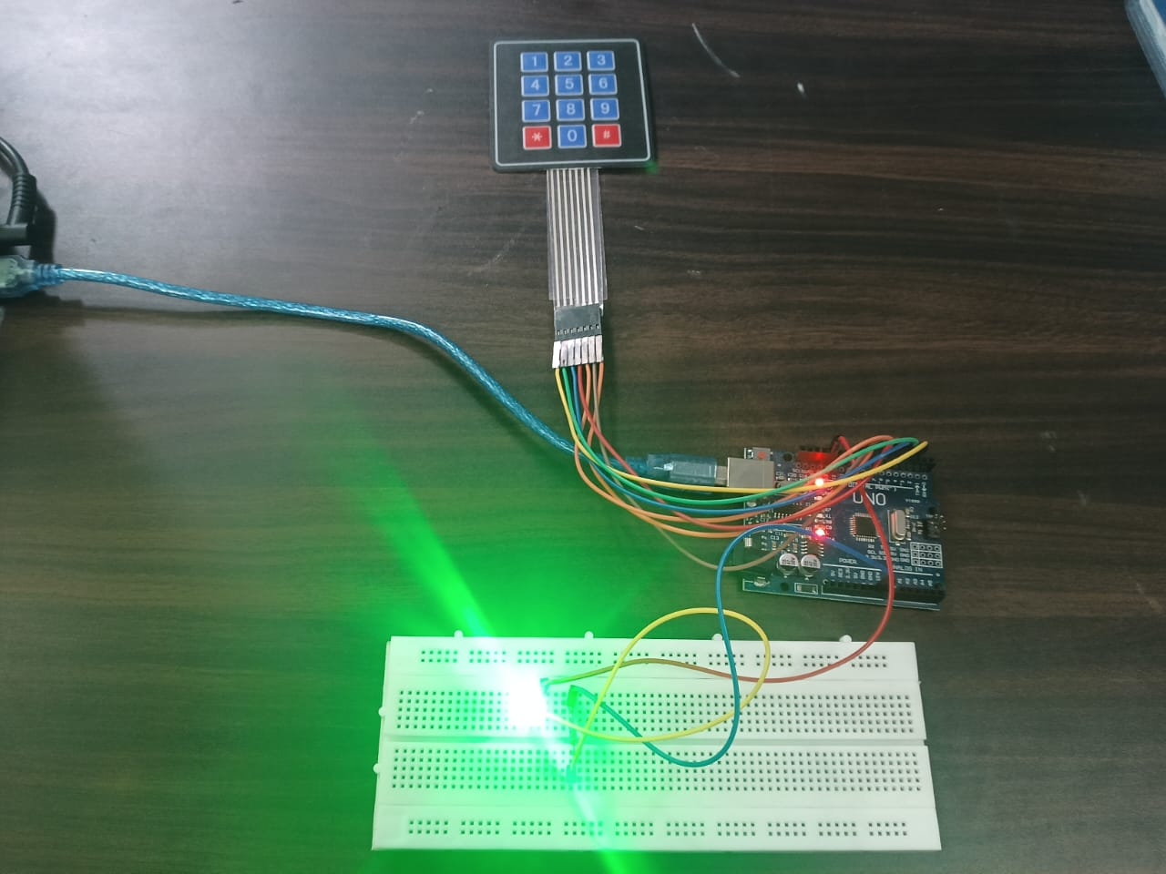

3.1 Workflow Diagram

WORKFLOW:

- Start and power on the Arduino.
- Initialise the LCD, keypad, LED and buzzer.
- Display "Enter Password" on the LCD.
- Read a key from the keypad. Each digit is added to the input buffer and shown as *.
- If the * key is pressed, clear the buffer and return to step 3.
- If the # key is pressed, compare the buffer with the stored password.
- If the password matches: turn the LED ON, display "Access Granted" and reset the attempt counter.
- If it does not match: sound the buzzer, display "Wrong Password" and increase the attempt counter.
- If the counter reaches 3, display "System Locked" and disable the keypad for 30 seconds. Then reset the counter.
- If the D key is pressed after access is granted, turn the LED OFF and re-lock the system.
- Return to step 3.

SYSTEM ARCHITECTURE
The system has three main blocks: the input block, the processing block and the output block.
The input block is the 4×4 matrix keypad. It has 16 keys, arranged in 4 rows and 4 columns and connected to 8 Arduino pins. Pressing a key connects one row to one column, and the Arduino identifies the key by scanning the rows and columns.
The processing block is the Arduino Uno. It reads keypresses, stores the digits, compares the entered password with the stored one, counts wrong attempts and decides the output action.
The output block consists of the LED, the 16×2 I2C LCD and the buzzer. The LED shows the state of the controlled load. The LCD shows prompts and status messages. The buzzer gives an audible alert for wrong entries and lockout.
The whole system is powered from the 5 V supply of the USB port or an external 9 V adapter. Fig 3.2 shows the block diagram.

HARDWARE DESCRIPTION

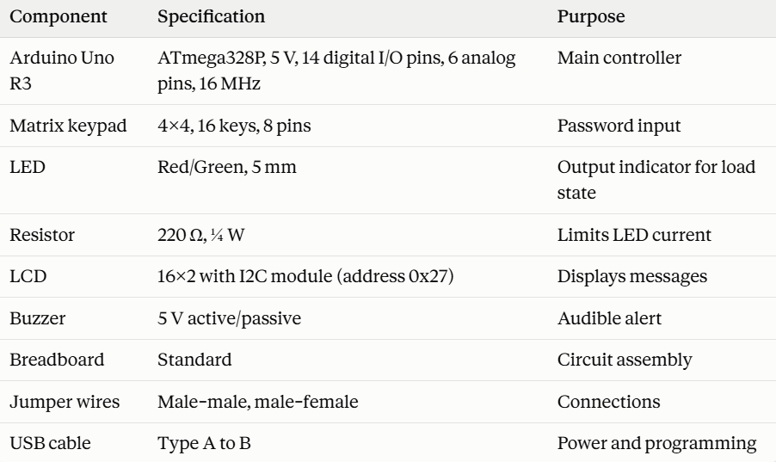

Arduino Uno. The Arduino Uno is a development board based on the ATmega328P microcontroller. It has 32 KB of flash memory for the program, 2 KB of SRAM and 1 KB of EEPROM. It operates at 5 V with a 16 MHz clock. Each I/O pin can supply up to about 20 mA safely.

4×4 Matrix Keypad. A matrix keypad reduces the number of pins required by arranging keys in rows and columns. Instead of 16 pins for 16 keys, only 8 are needed. The microcontroller drives the rows and reads the columns to detect which key is pressed.

LED and Resistor. With a 5 V supply, a red LED with a forward voltage of about 2 V and a 220 Ω resistor draws a current of I = (5 − 2) / 220 ≈ 13.6 mA, which is safe for the Arduino pin.

16×2 LCD with I2C. The LCD displays 16 characters on each of two lines. The I2C module reduces the connection to four wires (VCC, GND, SDA, SCL), which saves pins on the Arduino.

Buzzer. The buzzer produces a sound when driven by the Arduino, and is used with the tone() function to give different alert tones.

SOFTWARE DESCRIPTION

The program is written in the Arduino IDE using C/C++. The main libraries are:
- Keypad.h for scanning the matrix keypad and handling debouncing.
- LiquidCrystal_I2C.h for controlling the LCD through I2C.
- EEPROM.h (optional) for storing the password permanently.
The program has two main functions. The setup() function runs once at start-up. It configures the LED and buzzer pins as outputs, initialises the LCD and displays the first prompt. The loop() function runs continuously. It reads a key from the keypad and performs the appropriate action: adding a digit to the buffer, clearing the buffer, submitting the password or locking the system. Important variables are the constant string holding the stored password, a string buffer for the current input, and an integer counter for wrong attempts. The complete program is given in Appendix A.

CIRCUIT CONNECTIONS AND WORKING PRINCIPLE

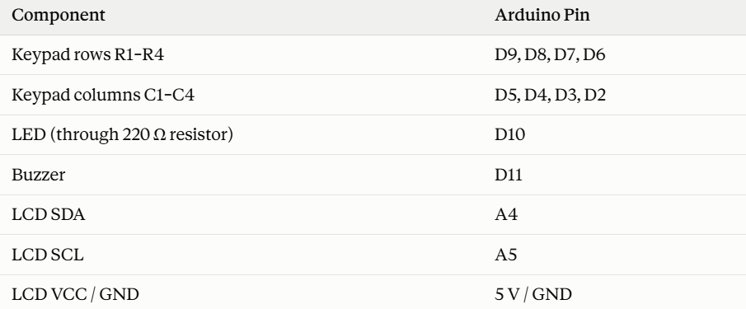

Working principle. When power is applied, the LCD displays "Enter Password". The user types the digits on the keypad, and each digit appears as an asterisk on the second line of the display. Pressing # submits the entry. The Arduino compares the entry with the stored password.
If the passwords match, pin D10 goes HIGH, current flows through the resistor and LED, and the LED glows. The LCD shows "Access Granted". The LED stays on until the user presses D to switch it off and re-lock the system.
If the passwords do not match, the LED stays off, the buzzer sounds and the LCD shows "Wrong Password". The attempt counter increases by one. When three consecutive wrong entries have been made, the LCD shows "System Locked" and the keypad is ignored for 30 seconds. After this, the counter resets and the system is ready again.

PERFORMANCE EVALUATION PARAMETERS

The system is evaluated on the following parameters:

Functional correctness: whether the LED turns on only for the correct password.

Response time: the time between pressing # and the LED or message responding.

Reliability: the consistency of correct operation over repeated trials.

Lockout behaviour: whether the system locks after three wrong attempts and unlocks after the set time.

Keypad accuracy: whether each keypress is registered once, without false or missed entries.

Power consumption: the current drawn by the complete circuit.

CONCLUSION

This chapter described the limitations of existing systems, the advantages of the proposed system, and its flow, architecture, hardware, software, circuit connections and working principle. The evaluation parameters were also defined. The next chapter presents the results obtained from simulation and hardware testing.

CHAPTER 4 RESULTS AND DISCUSSIONS

EXPERIMENTAL SETUP

The system was developed and tested using an Arduino Uno R3 board programmed through the Arduino IDE [version]. The circuit was first simulated in [Tinkercad / Proteus] and then assembled on a breadboard. The components used were a 4×4 matrix keypad, a 16×2 I2C LCD, a red LED with a 220 Ω resistor and a buzzer. The system was powered from the 5 V USB supply of a laptop. The stored test password was [1234]. The lockout limit was set to three attempts with a lock time of 30 seconds.

SIMULATION RESULTS

The circuit was simulated before hardware assembly to verify the logic and connections. In the initial state, the LED was off and the LCD displayed "Enter Password" (Fig 4.1). When a wrong password was entered, the buzzer sounded, the LED stayed off and "Wrong Password" was displayed (Fig 4.2). When the correct password was entered, the LED turned on and "Access Granted" was displayed (Fig 4.3). The simulation confirmed that the program logic and pin assignments were correct and allowed errors to be removed before building the hardware.

  - HARDWARE IMPLEMENTATION RESULT

After successful simulation, the circuit was built on a breadboard as shown in Fig 4.4. The hardware behaved in the same way as the simulation. Each keypress was registered and shown as an asterisk on the LCD. The correct password switched on the LED, and wrong passwords activated the buzzer. Fig 4.5 shows the LCD messages in the different operating states, and Fig 4.6 shows the display when the system locks after three wrong attempts.

TEST CASES AND OBSERVATIONS

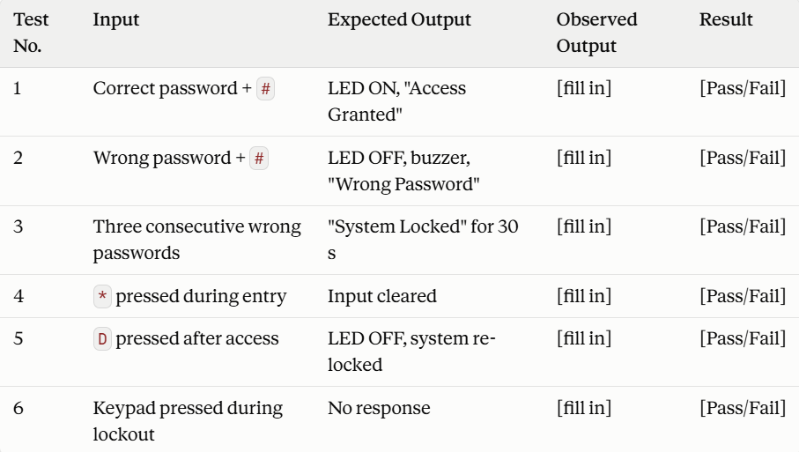

RESPONSE TIME AND RELIABILITY ANALYSIS

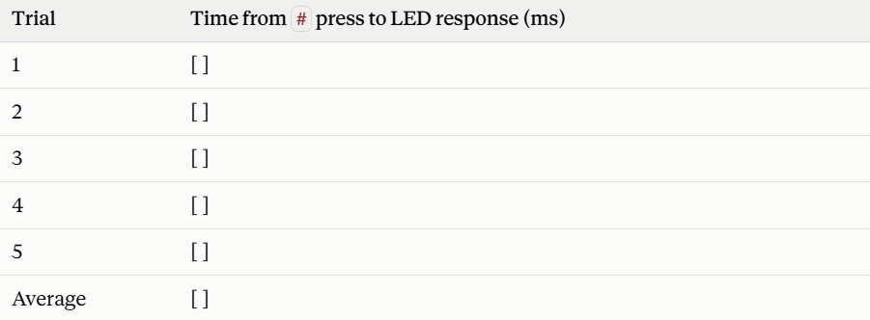

The response time was [well below 100 ms], which appears instant to the user. To check reliability, the system was tested for [50] repeated attempts with a mix of correct and incorrect passwords, and it responded correctly in [50 out of 50] attempts. The Keypad library's built-in debouncing prevented duplicate entries, even when keys were pressed quickly. The system also behaved consistently across repeated power cycles.

CONCLUSION

The results show that the password-based LED control system works as designed. It grants access only for the correct password, gives clear feedback and blocks repeated wrong attempts. Simulation and hardware results were consistent. The limitations are that the password is typed on an open keypad and can be seen by someone watching, and that a fixed password stored in the code is not fully secure. These can be improved in future work.

CHAPTER 5 CONCLUSION

CONCLUSION
This project presented the design, simulation and implementation of a password-based LED control system using the Arduino Uno. The system uses a 4×4 matrix keypad for password entry, an LCD for display, a buzzer for audio feedback and an LED as the controlled output. The controller verifies the entered password and switches the LED on only for the correct one. Password masking and a lockout after three wrong attempts add basic security.
Testing in simulation and on hardware showed that the system responds correctly and quickly, and operates reliably over repeated trials. The design is inexpensive, simple to build and easy to modify. It demonstrates the basic principle of access control and can serve as a foundation for practical security and automation applications.

SUGGESTIONS FOR FUTURE WORK

Several improvements can be made to this system:
- Add a password-change option with EEPROM storage so the password survives power loss.
- Replace the LED with a relay module to control real appliances, or a solenoid lock for door access.
- Add Bluetooth or Wi-Fi control through a mobile application using an HC-05 or ESP8266/ESP32 module.
- Add RFID or fingerprint authentication for two-factor security.
- Add GSM alerts that send an SMS to the owner after repeated wrong attempts.
- Add a real-time clock (RTC) and SD card to keep a time-stamped log of all access attempts.

REFERENCES

• Arduino, Arduino UNO Rev3 – Technical Specifications, Arduino Official Documentation.
https://docs.arduino.cc/hardware/uno-rev3/
• Arduino, Arduino Language Reference, Arduino Official Documentation.
https://docs.arduino.cc/language-reference/
• Arduino, Keypad Library, Arduino Libraries Documentation.
https://www.arduino.cc/reference/en/libraries/keypad/
• Arduino, Arduino UNO Rev3 Datasheet, Arduino Documentation.
https://docs.arduino.cc/resources/datasheets/A000066-datasheet.pdf
• M. Margolis, B. Jepson and N. Weldin, Arduino Cookbook, 3rd Edition, O'Reilly Media, 2020.
• Simon Monk, Programming Arduino: Getting Started with Sketches, 2nd Edition, McGraw-Hill Education, 2016.
• Michael McRoberts, Beginning Arduino, 2nd Edition, Apress, 2013.

Appendix A: Sample Arduino Code

cpp
#include <Keypad.h>
#include <LiquidCrystal_I2C.h>

const byte ROWS = 4, COLS = 4;
char keys[ROWS][COLS] = {
{'1','2','3','A'},
{'4','5','6','B'},
{'7','8','9','C'},
{'*','0','#','D'}
};
byte rowPins[ROWS] = {9, 8, 7, 6};
byte colPins[COLS] = {5, 4, 3, 2};
Keypad keypad = Keypad(makeKeymap(keys), rowPins, colPins, ROWS, COLS);
LiquidCrystal_I2C lcd(0x27, 16, 2);

const int LED = 10, BUZZER = 11;
const String PASSWORD = "1234";
String input = "";
int attempts = 0;

void setup() {
pinMode(LED, OUTPUT);
pinMode(BUZZER, OUTPUT);
lcd.init(); lcd.backlight();
lcd.print("Enter Password");
}

void loop() {
char key = keypad.getKey();
if (!key) return;

if (key == '#') {
lcd.clear();
if (input == PASSWORD) {
digitalWrite(LED, HIGH);
lcd.print("Access Granted");
attempts = 0;
} else {
lcd.print("Wrong Password");
tone(BUZZER, 1000, 500);
if (++attempts >= 3) {
lcd.clear(); lcd.print("System Locked");
delay(30000);
attempts = 0;
}
}
delay(1500);
input = "";
lcd.clear(); lcd.print("Enter Password");
} else if (key == '*') {
input = "";
lcd.clear(); lcd.print("Enter Password");
} else if (key == 'D') {
digitalWrite(LED, LOW); // lock / turn LED off
} else {
input += key;
lcd.setCursor(input.length() - 1, 1);
lcd.print('*');
}
}

